This is a tentative list of instruments. Quantity may vary.

* Atmega32 - 6 ones
* Atmega Burner or USBASP programmer
* Breadboard (1 ps)
* Jumper Wires (male-to-male, male-to-female, female-to-female) (30-40 ps each)(you will probably need it in large numbers for project)
* Push Buttons (5 ps)
* LEDs (5-10 ps)
* Resistors (220 ohm, 1k ohm, 2.2k ohm, 10k ohm) (10-20 ps each)
* Bicolor (red-green) 8x8 LED matrix

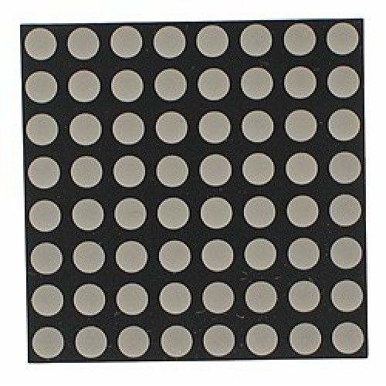

* 16x2 LCD display module (Caution: you have to connect male connector row with LCD display, male connector row is explained below)

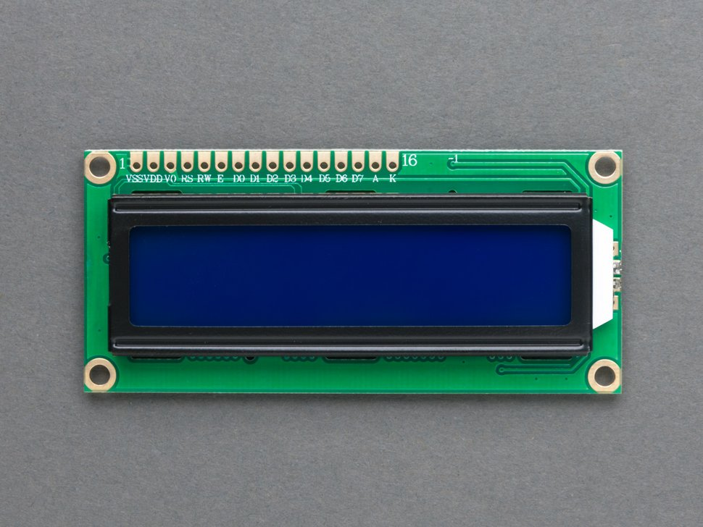

* Male connector row

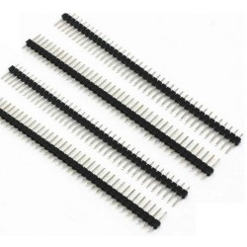

You need to solder male connector to the LCD display. Do not try to solder if you are not somewhat expert in this. Yo’u can ask other expert people to do that for you. Here’s a video <https://www.youtube.com/watch?v=E9NIN49iiCc>. Or, if you can buy an LCD display with male connector attached to it, that would be great.

* Potentiometer

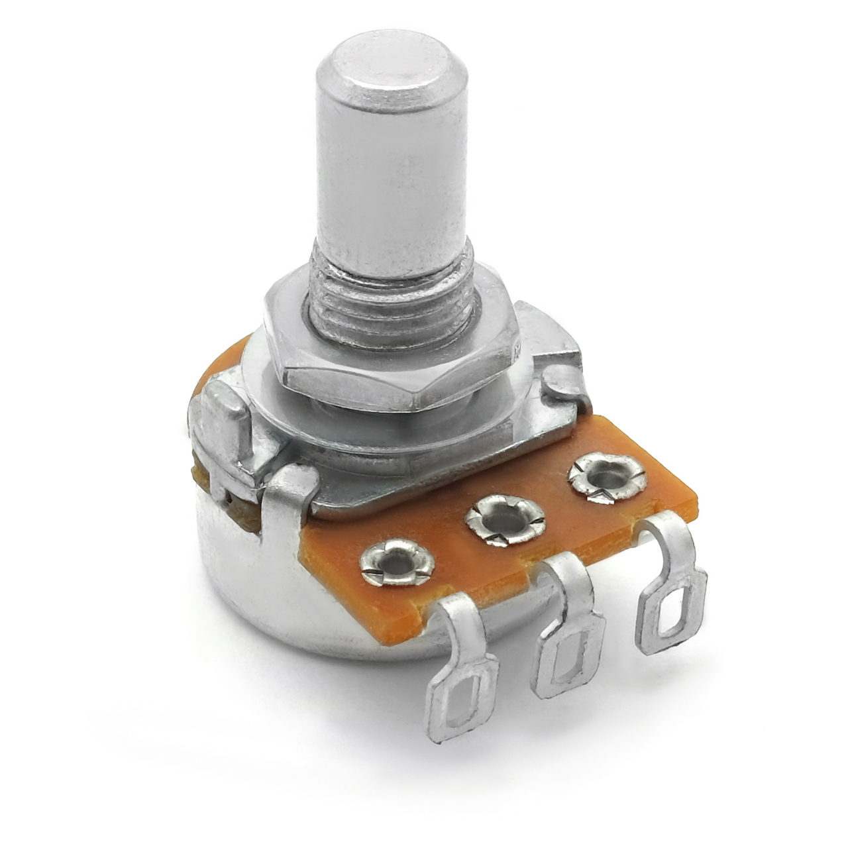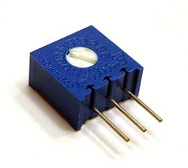

* Multimeter (This is not necessary but very appreciated. You can buy 1 piece for a whole group.)

